



**Topic : Transmission Media**

**Submitted to:**

Diljith K Benny

Assistant Professor

Department of Computer

Science

**Submitted by:**

Muhammad Anshad P A

Roll No:36

MCA - 1st Year

**MCA104**

**Date:** 09/08/2023

**ASSIGNMENT**

**INTRODUCTION**

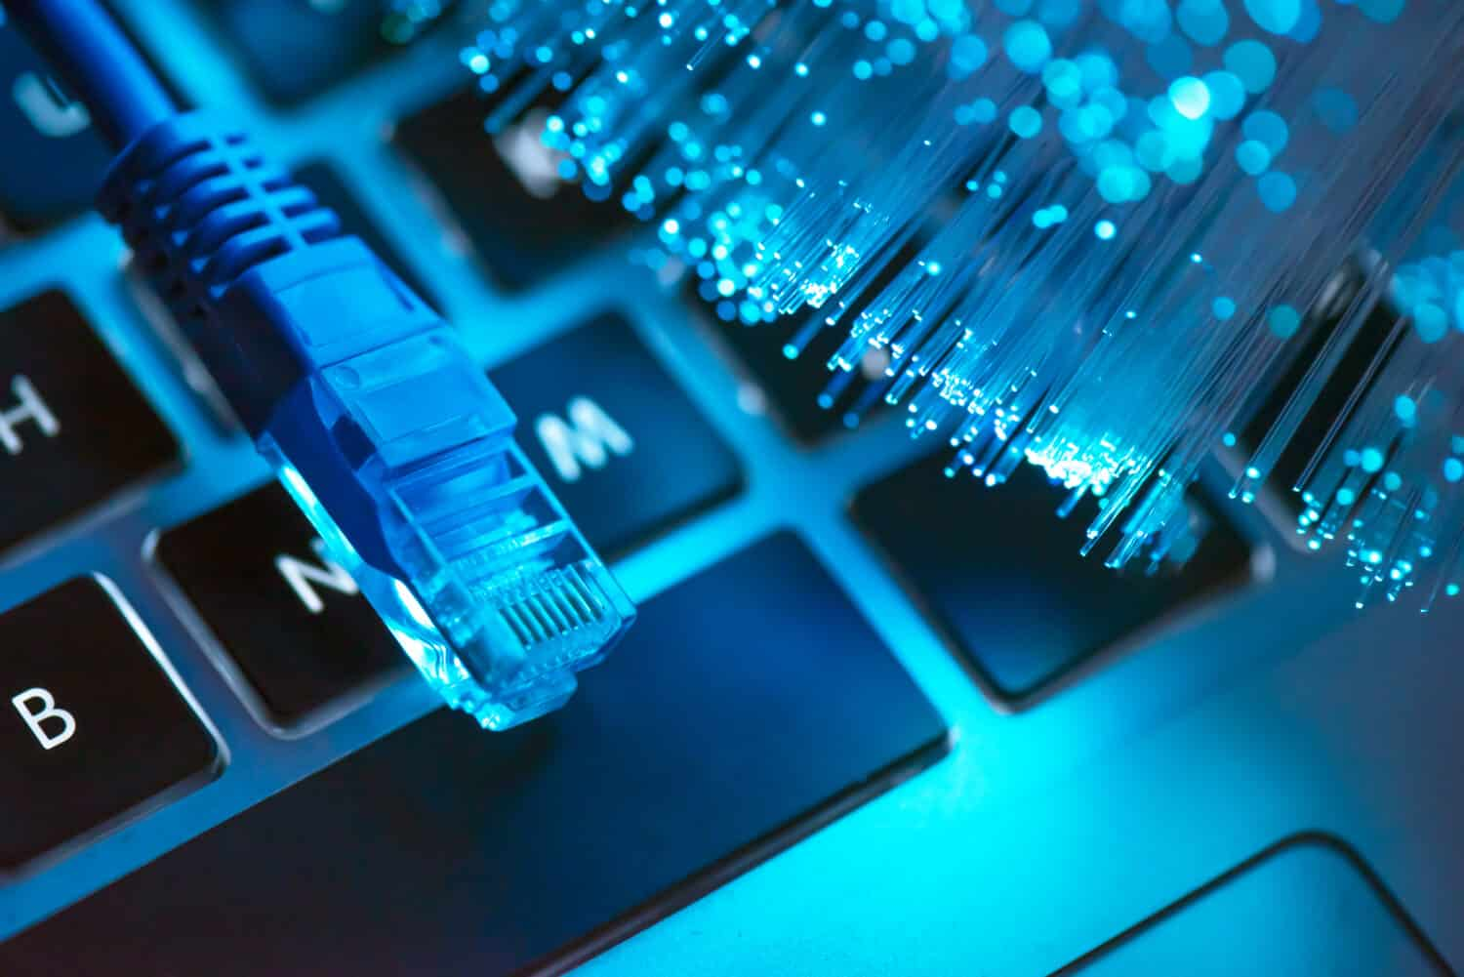

**Transmission media play a crucial role in computer networks by providing the physical means to carry data signals from one device to another. They serve as the communication channels through which information travels, connecting computers, servers, routers, and other network devices. This report aims to explore various transmission media used in computer networks, their characteristics, advantages, and disadvantages.**

**What is Transmission Media?**

* **Transmission media is a pathway that carries the information from sender to receiver.**
* **We use different types of cables or waves to transmit data.**
* **Data is transmitted normally through electrical or electromagnetic signals.**
* **Transmission media are located below the physical layer.**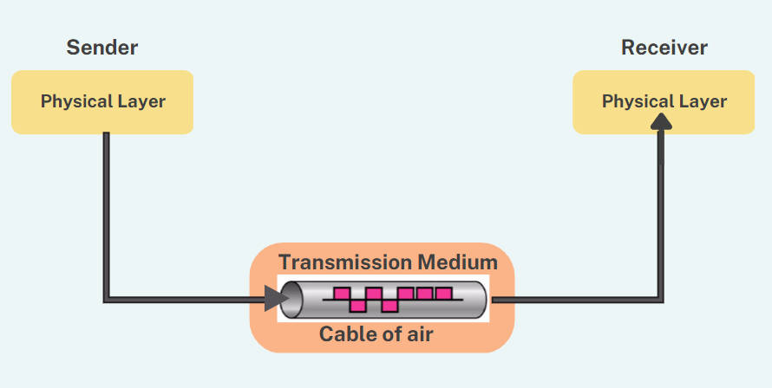



**Some factors need to be considered on designing the transmission media:**

* **Bandwidth:** The greater the bandwidth of a medium, the higher the data transmission rate of a signal.
* **Transmission impairment:** When the received signal is not identical to the transmitted one due to the transmission impairment. The quality of the signals will get destroyed due to transmission impairment.
* **Interference:** An interference is defined as the process of disrupting a signal when it travels over a communication medium on the addition of some unwanted signal.



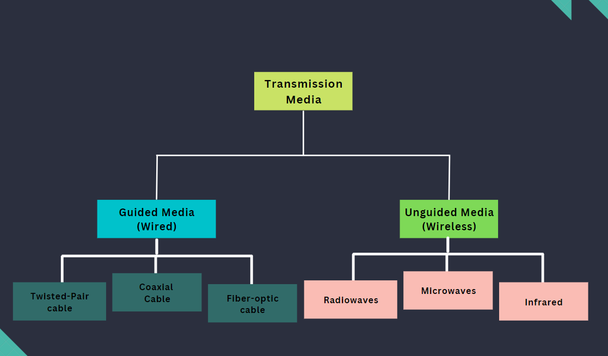

**Classification of Transmission media:**

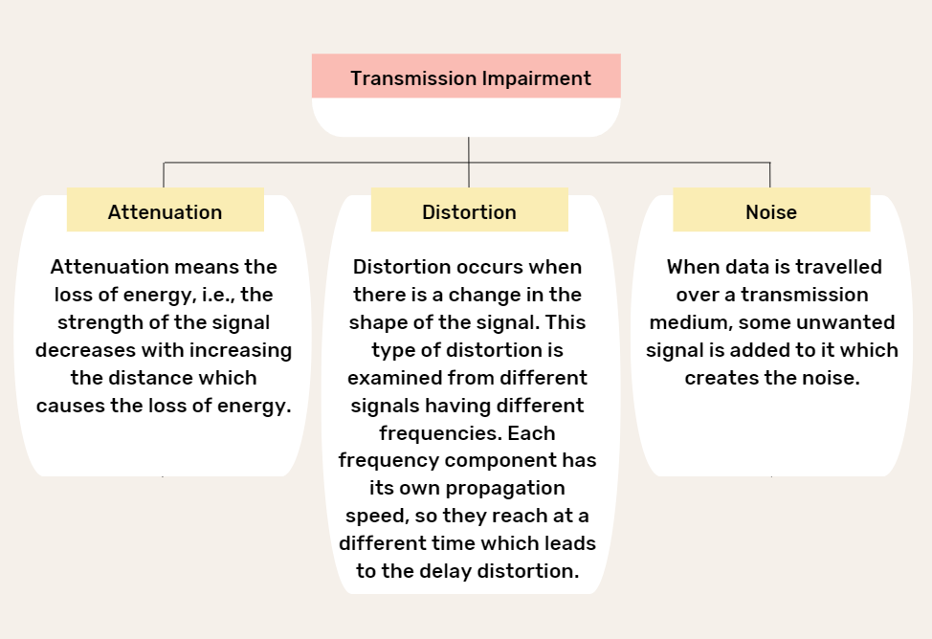

**Causes Of Transmission Impairment: designing the transmission media:**



**A transmission medium is a route that transmits information from a source to a receiver. Transmission mediums lie underneath the physical layer and the physical layer regulates them. Communication channels are another name for transmission medium.**

**There are 2 types of transmission media:**

1. **Guided Media(Wired)**
2. **Unguided Media(Wireless)**

**Twisted-Pair Cable**

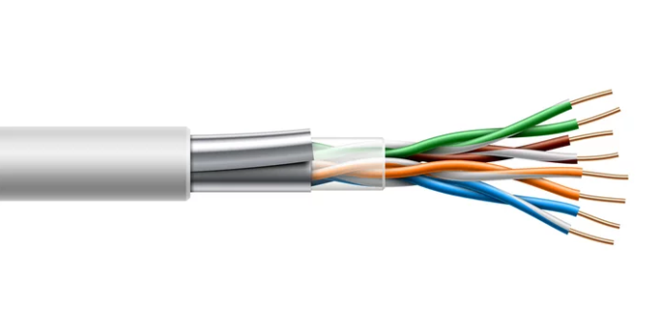

**1**

**Bounded media and wired media are other names for guided transmission media. They consist of cables or wires that transfer data. They go by the name “guided” because they act as a physical link between the transmitter and recipient devices. The physical limitations of the medium limit the signal flowing via these mediums. They are:**

* **Secure .**
* **High-speed .**
* **Generally used for shorter distances.**

**Some of these most popular guided transmission media are:**

**1. Guided Transmission Media:**



**Appications:**

* Used in telephone network.
* Used for Local Area Networks(LAN).

**Disadvantages:**

1. Low data rate.
2. Short range.

**Twisted**

**Pair**

* **Provides protection against cross talk or interference(noice).**
* **One wire is used to carry signals to the reciever.**
* **Second wire is used as a ground reference.**
* **Number of twists per unit length,determines the quality of cable.**

**Advantages:**

1. Cheap.
2. Easy to work with.

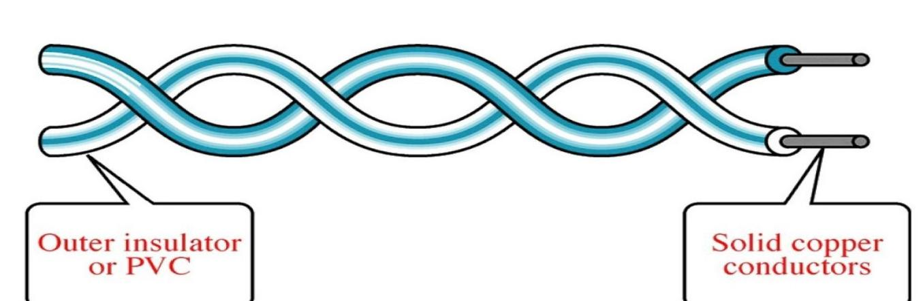

* **It is the most widely used transmission medium cable.**
* **Consists of two distinct insulated conductor wires coiled around each other with its own plastic insulation.**



1. **Unshielded Twisted Pair(UTP):**

* **It is apair of unshielded wires wound around each other.**
* **Provides a high speed link.**
* **The most affordable.**
* **Simple to set up.**
* **External interference is a possibility.**
* **When compared to Shielded Twisted Pair, it has a lower capacity and performance.**

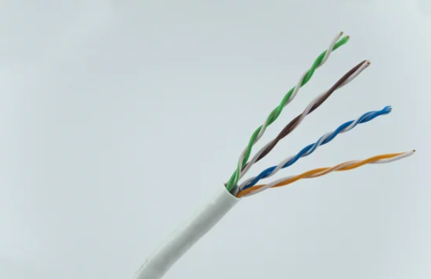

**There are 2 broad types of twisted-pair cables:**

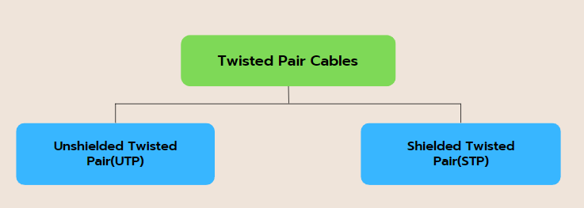



**UTP Cable types:**

**.**

|  |  |  |  |
| --- | --- | --- | --- |
| ****UTP Cable Category**** | ****Grade**** | ****Business Application**** | ****Frequency****  ****Range**** |
| **CAT 1 Cables** | **voice grade** | **Only telephone networks voice-grade Not suitable for data transmissions-** | **750 kHz** |
| **CAT 2 Cables** | **voice grade** | **telephone networks voice-grade, mainframe computers IBM dumb-terminal connections** | **1 MHz** |
| **CAT 3 Cables** | **data grade** | **voice-grade telephone networks, 4Mbps Token Ring, 10Mbps Ethernet 100BaseT4 Fast Ethernet, and 100 VG Any LAN** | **16 MHz** |
| **CAT 4 Cables** | **data grade** | **16Mbps Token Ring networks** | **20 MHz** |
| ****CAT 5 Cables**** | **data grade** | **100BastTX Fast Ethernet, OC-3 ATM networks, and SONET** | **100 MHz** |
| **CAT 5e Cables** | **data grade** | **Gigabit (1000Mbps) Ethernet** | **100 MHz** |
| ****CAT 6 Cables**** | **data grade** | **Gigabit (1000Mbps) Ethernet** | **250 MHz** |
| **CAT 6a Cables** | **data grade** | **Gigabit (1000Mbps) & 10 Gigabit Ethernet** | **500 MHz** |
| ****CAT 7 Cables**** | **Data grade** | **1 Gbps or higher Ethernet-based computer networks** | **600 MHZ** |

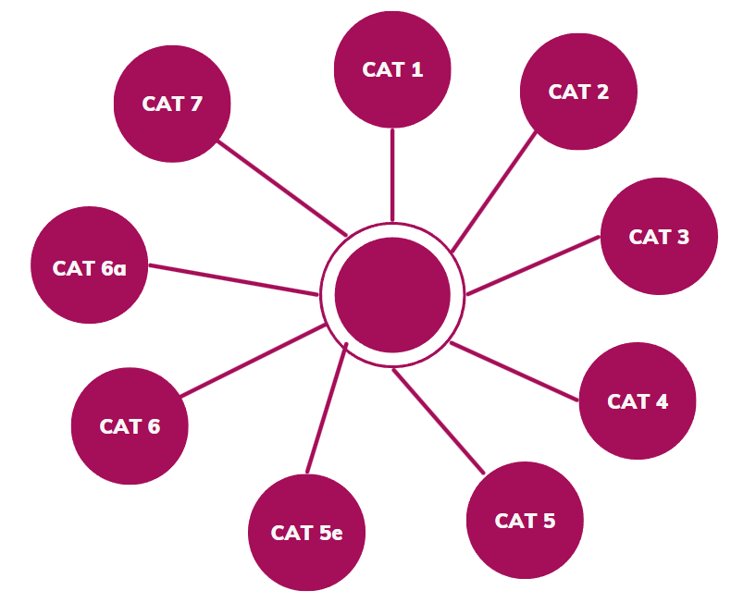



**Disadvantages of UTP:**

1. Suffers from external Electromagnetic interference.

**Advantages of UTP:**

1. It is inexpensive.
2. simple to install.
3. It is suitable for high-speed LAN.

**UTP Connector and Tools:**

**RJ45(registered jack):**

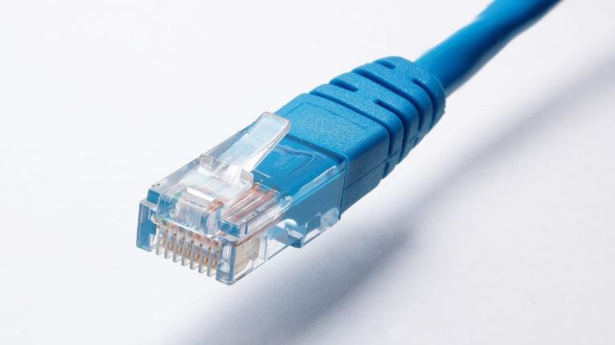

**Crimper Tool:**

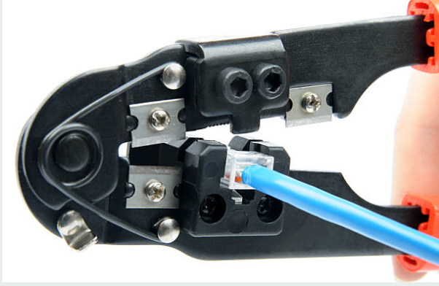



**Coaxial Cable**

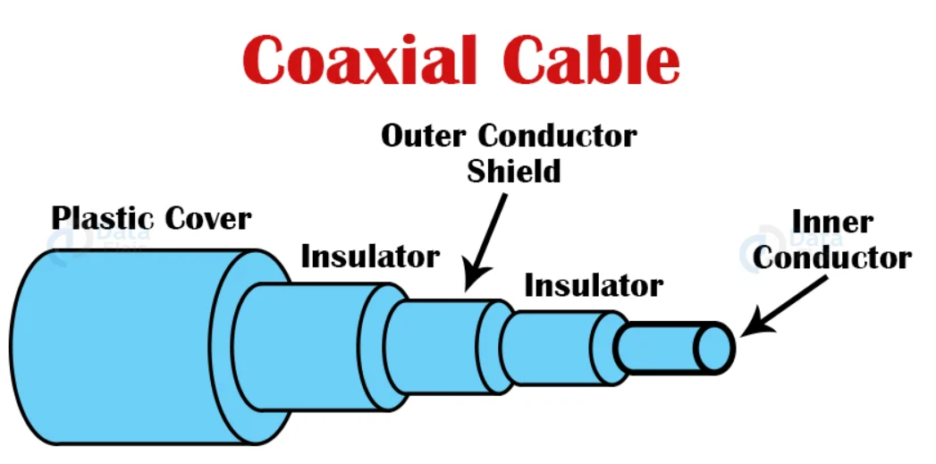

**2**

**Disadvantages of STP:**

1. It is more costly than UTP and coaxial cable.
2. It has a greater rate of attenuation.Applications:
3. Local Area Networks
4. Telephone Lines

**Advantages of STP:**

1. STP installation is simple.
2. It has a larger capacity than unshielded twisted pair cable.
3. Higher rate of transmission.
4. **Shielded Twisted Pair(STP):**

* **Installation and manufacturing are both somewhat challenging.**
* **Pricier.**
* **When compared to Unshielded Twisted Pair, it performs better at greater data rates.**
* **Faster in comparison.**

.

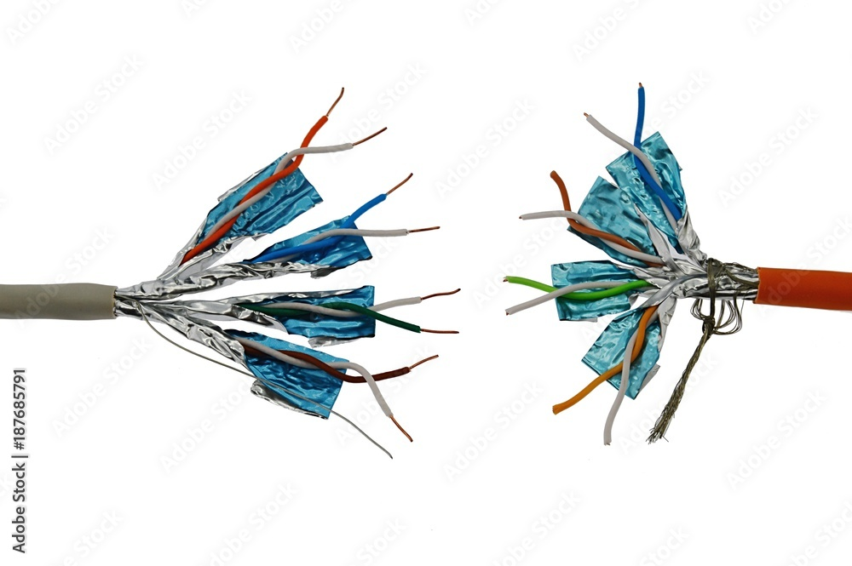



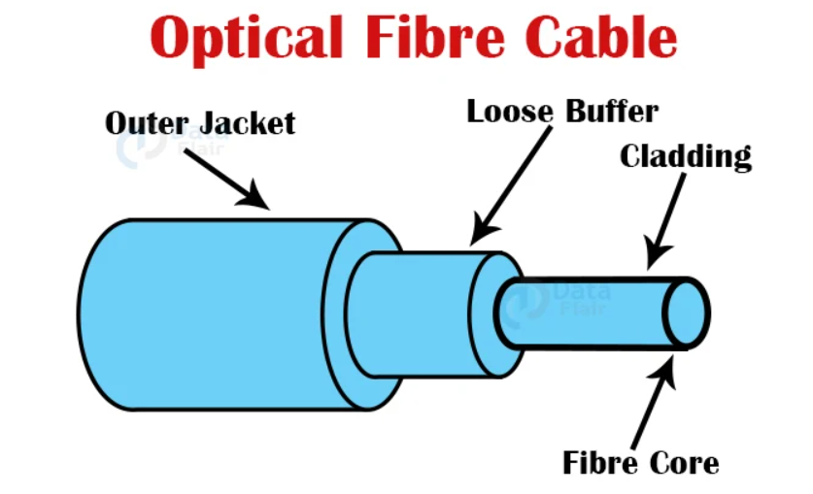

**Fibre-Optic Cable**

**3**

**Disadvantages:**

1. If there is a failure of the cable, the whole network may fail.
2. Single cable failure can takedown an entire network .

**Advantages :**

1. High bandwidth.
2. Less susceptible to noise.
3. Very cheap to install.
4. Easy to install and upgrade.

* **It features an exterior plastic covering and two parallel conductors, each with its own insulated protective cover. It operates in 2 ways: baseband and broadband.**

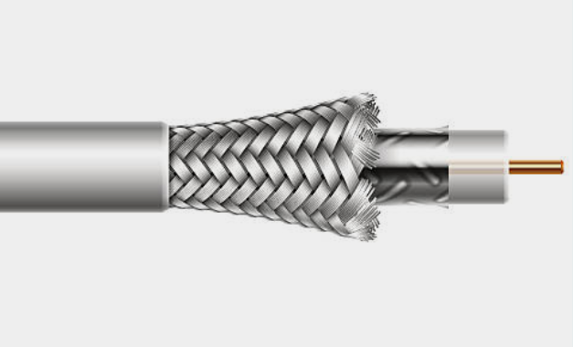



**Advantages :**

1. Does not rust or corrode since there is no metal.
2. Can transmit data at very high speed.
3. Supports high bandwidth.
4. There is less signal attenuation.
5. Resistance to electromagnetic interference.

**Disadvantages:**

1. Installing and maintaining it is difficult.
2. Fragile and expensive.

* **It works on the principle of light reflection through a core composed of glass or plastic.**
* **The cladding surrounds the core, and the cladding is a less thick glass or plastic covering. It finds use in large-volume data transfer.**
* **It is possible for the cable to be unidirectional or bidirectional.**

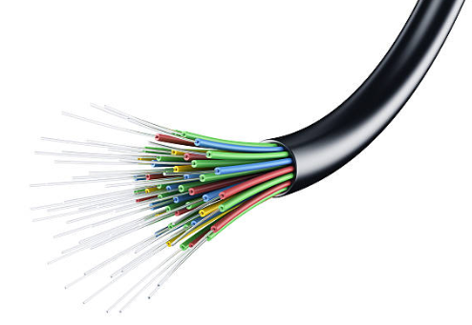



**Advantages :**

1. Radio transmission is mostly utilized for wide area networks and mobile phones.
2. Radio waves may penetrate barriers and cover a broad area.
3. Faster transmission speed.

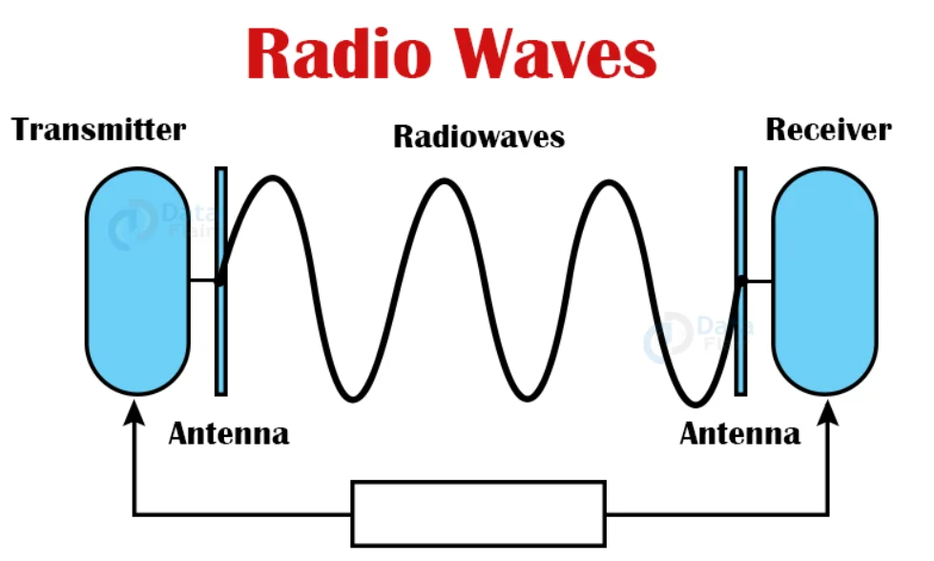

* **Very commonly used and very simple to generate.**
* **These types of waves can pass through obstacles easily.**
* **Two antennas are used, one for the transmitting station and one for the receiving station (these antennas need not be aligned).**
* **The frequency ranges from 3 kHz to 1GHz.**

**Radio Waves:**

**1**

**Electromagnetic signals can also be transmitted without the use of a physical medium. These are also known as wireless or unbounded transmission media.**

**Some properties of unguided media are:**

* **Less secure than guided media.**
* **Used for longer distances.**

**Types of Unguided Transmission Media :**

**2. Unguided Transmission Media:**



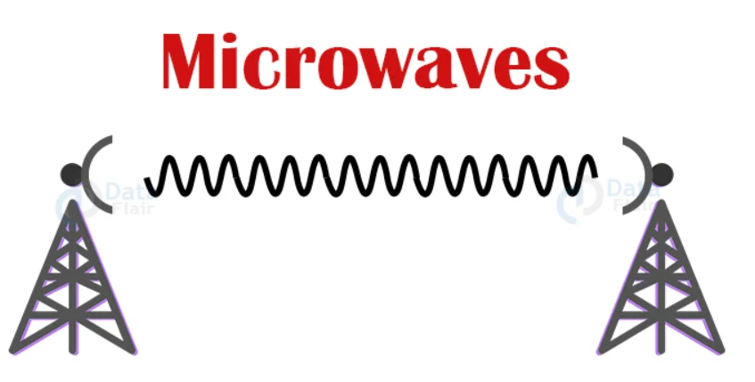

* **It is a line-of-sight transmission, which means that the transmitting and receiving antennas must be correctly aligned.**
* **The distance reached by the signal is proportional to the antenna’s height. These are mostly utilized for mobile phone communication and television broadcasting.**
* **Frequency range: 4 to 23 GHz.**
* **Bandwidth: It provides bandwidths ranging from 1 to 10 Mbps.**
* **Short distance: Suitable for short distance communication.**
* **Long distance: It is costly since a larger tower is required for a longer distance.**
* **Attenuation: Weakening of a signal is referred to as attenuation. Antenna size can change attenuation.**

**2**

**Micro Waves:**

**Applications :**

1. AM and FM Radio.
2. Cordless Phone

**Disadvantages :**

1. Regulation of radio spectrum, thus it is expensive to buy.
2. Cannot permeate matter very well.
3. Cannot travel above the horizon because of the curvature of the earth.

**4**



**Advantages :**

1. Microwave transmission is cheaper than cable transmission.
2. It does not necessitate the acquisition of land since the installation of cables does not necessitate the acquisition of land.
3. Microwaves are more convenient in places where installing cables is difficult.
4. Microwave transmission can be used to communicate across seas.

**Disadvantages :**

1. **Eavesdropping**: Eavesdropping makes communication unsafe. Any rogue user with its own antenna can capture the signal in the air.
2. **Out of phase signal**: Signal may shift out of phase.
3. **Weather condition**: Any environmental disturbance may cause the signal distortion.
4. **Bandwidth allocation**: Less bandwidth is available.

**Applications :**

1. **Satellite Networks**
2. **Cell phones**

**3**

**Infrared:**

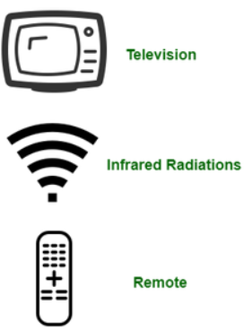

* **When there is a need for very short-range communication, infrared waves are used. However, they fail to penetrate any walls/obstacles in the way of the signal.**
* **The frequency ranges from 300 GHz to 400 THz.**
* **It has a large bandwidth, thus the data rate will be quite high.**
* **Infrared waves are unable to permeate the walls. As a result, infrared communication in one room cannot be disrupted by surrounding rooms.**
* **Infrared communication is more secure and also causes less interference.**
* **Outside the building, infrared communication is unreliable because the sun’s rays interfere with the infrared radiation.**

**Disadvantages :**

1. Cannot cross barriers.
2. Long-range communication is not possible.

**Advantages :**

1. Cost-effective and cheap.
2. Large bandwidth.
3. Easy to install.
4. Can be operated without any licence.

**Applications :**

1. Short-range communication
2. Communication between keyboards, PCs and mouse.



1. **Data Flair**
2. **Geeksforgeeks**
3. **Slideshare**



**-REFERENCES-**